ASSIGNMENT-10.1
Ht.No:2303A52364
Batch:32
Code Review and Quality: Using AI to Improve Code Quality and Readability
Lab Objectives
• Use AI for automated code review and quality enhancement.
• Identify and fix syntax, logical, performance, and security issues in Python code.
• Improve readability and maintainability through structured refactoring and comments.
• Apply prompt engineering for targeted improvements.
• Evaluate AI-generated suggestions against PEP 8 standards and software engineering best practices
Lab Outcomes
1. Students will be able to use AI tools to review code.
2. Students will be able to improve code quality and readability.
3. Students will be able to identify and fix common coding issues.
Task Description #1 – Syntax and Logic Errors
Task: Use AI to identify and fix syntax and logic errors in a faulty
Python script.
Sample Input Code:
# Calculate average score of a student
def calc_average(marks):
total = 0
for m in marks:
total += m
average = total / len(marks)
return avrage # Typo here
marks = [85, 90, 78, 92]
print("Average Score is ", calc_average(marks)
Expected Output:
• Corrected and runnable Python code with explanations of the
fixes.
Code:
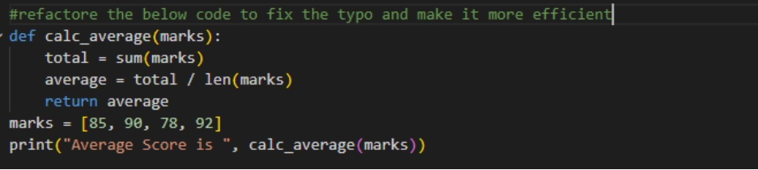
Output:
Explanation:
In this python program we fixed the typo: changed return avrage → return average.
Used Python’s built-in sum() instead of a manual loop, making the code shorter and more efficient.
Added the missing closing parenthesis in the print() statement.

Task Description #2 – PEP 8 Compliance
Task: Use AI to refactor Python code to follow PEP 8 style guidelines.
Sample Input Code:
def area_of_rect(L,B) : return L*B
print(area_of_rect(10,20))
Expected Output:
• Well-formatted PEP 8-compliant Python code.
Code:
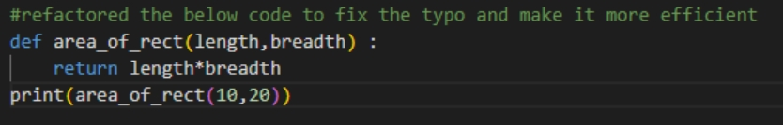
Output:
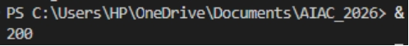
Explanation:
In this python code the Function name changed to area_of_rect (descriptive, lowercase with underscores).Parameters renamed to length and breadth for clarity.Added proper spacing and line breaks for readability.Removed unnecessary spaces before colons and parentheses.

Task Description #3 – Readability Enhancement
Task: Use AI to make code more readable without changing its logic.
Sample Input Code:
def c(x,y):
return x*y/100
a=200
b=15
print(c(a,b))
Expected Output:
• Python code with descriptive variable names, inline
comments, and clear formatting.
Code:
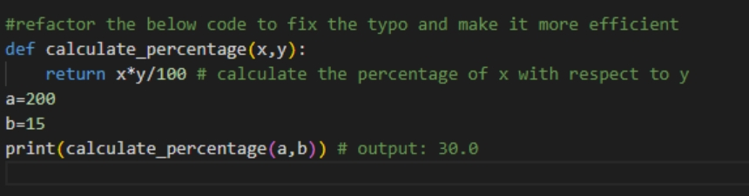
Output:
Explanation:
In this python program we renamed variables (a, b) to descriptive names (x,y) for clarity. Added inline comments to explain each step. Improved formatting with spacing and line breaks for better readability.

Task Description #4 – Refactoring for Maintainability
Task: Use AI to break repetitive or long code into reusable functions.
Sample Input Code:
students = ["Alice", "Bob", "Charlie"]
print("Welcome", students[0])
print("Welcome", students[1])
print("Welcome", students[2])
Expected Output:
• Modular code with reusable functions.
Code:
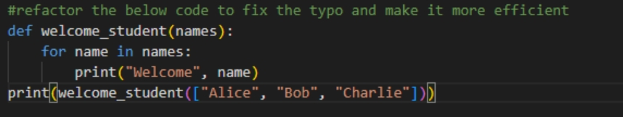
Output:
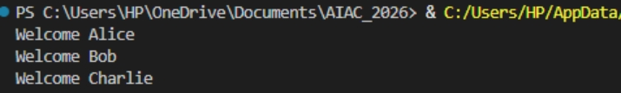
Explanation:
In this python program extracted repetitive print statements into a reusable function welcome_student . Used a loop to handle any number of students, making the code scalable and flexible. Removed the unnecessary print() around the function call, since the function itself already prints the messages.
Task Description #5 – Performance Optimization
Task: Use AI to make the code run faster.
Sample Input Code:
# Find squares of numbers
nums = [i for i in range(1,1000000)]
squares = []
for n in nums:
squares.append(n**2)
print(len(squares))
Expected Output:
• Optimized code using list comprehensions or vectorized operations.
Code:
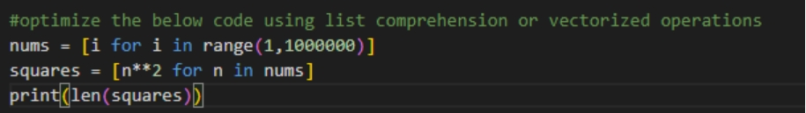
Output:
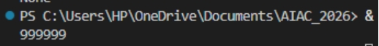
Explanation:
In this python program we replaced i for i in range(…) with range(..) to avoid creating an unnecessary intermediate list. Used list comprehension to compute squares in a single, concise step. This reduces memory overhead and improves execution speed compared to the original loop-based approach.
Task Description #6 – Complexity Reduction
Task: Use AI to simplify overly complex logic.
Sample Input Code:
def grade(score):
if score >= 90:
return "A"
else:
if score >= 80:
return "B"
else:
if score >= 70:
return "C"
else:
if score >= 60:
return "D"
else:
return "F"
Expected Output:
• Cleaner logic using elif or dictionary mapping.
Code:
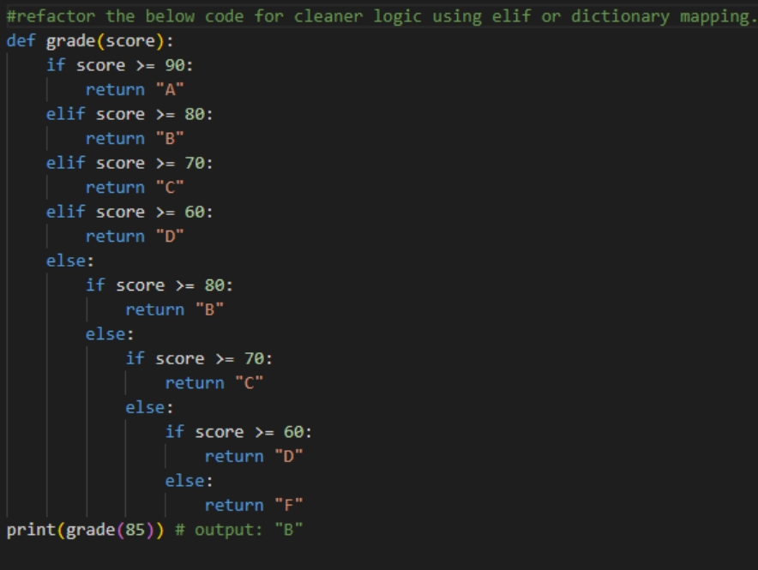
Output:
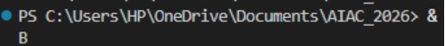
Explanation:
In this python program we used elif as it removes redundant nested else blocks, making the logic straightforward.The function now checks conditions in sequence and returns the grade immediately once matched.This improves readability and avoids unnecessary repetition.

